**PROJECT TITLE : EMPLOYEE APPRECIATION BASED ON CUSTOMER SATISFACTION**

**TEAM MEMBERS:**

**A.KOSHIK KUMAR**

**B.SREENU**

**V.MOUNIKA**

**G.RAJU**

**B.RAVALI**

**1 INTRODUCTION**

1.1 Overview

The way you treat your employees is the way they treat your customers According to a recent article, creating an employee recognition culture can increase employee retention by up to 31%. Employee recognition is the process of showing appreciation for an employee’s achievements, actions, and contributions. In big companies (Amazon/Swiggy/Uber ) appreciation is given to the employees based on the customer feedback or satisfaction (chat process/ voice process). Analyzing all the feedback of each customer towards an employee work manually is a tedious job.

1.2 Purpose

The main objective of this project is to appreciate the employee work based on analysis of customer feedback. We are designing an application where the HR/ user can upload the feedback report of all the employees. The analysis of each employee report is displayed on the Web application in the form of Bar charts.

**2 LITERATURE SURVEY**

2.1 Existing problem

* Reducing the financial impact of customer dissatisfaction.
* Controlling the cost of customer acquisition.
* Highlighting what is most attractive about your company's image.
* Reinforcing the relevance of your approach to continuous improvement.
* Improving the efficiency and the adequacy of your offerings.

2.2 Proposed solution

In a small company it is very evident if customers are dissatisfied. People complain directly to the proprietor. The situation is very different in a large company. Customers are dealt with by many different people. There are multiple touch points for any single customer which could cause dissatisfaction – the sales representation, the customer service team, the delivery people, the finance department and so on. The managers of the company undoubtedly have hundreds of customers, possibly scattered around the world, and the only way they can know for sure how satisfied they are is by carrying out a survey. This brings with it a number of potential problems and the survey itself is the least of these. Measuring customer satisfaction is easy compared to the task of implementing improvements.

**3 THEORITICAL ANALYSIS**

3.1 Block diagram

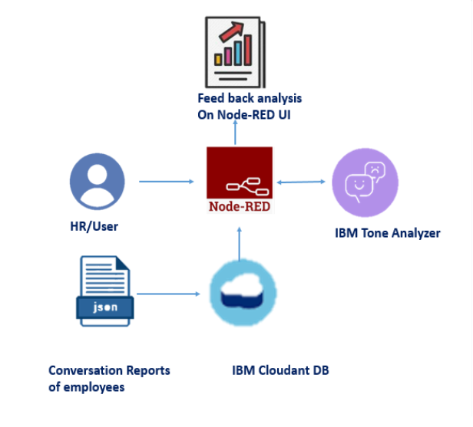

3.2 Hardware / Software designing

For this we need to create IBM Services, like Tone Analyser, Node-Red Service.

### Create Tone Analyser Service:

This service uses linguistic analysis to detect joy, fear, sadness, anger, analytical, confident and tentative tones found in text.

### Create Node-RED Service:

Node-RED is a programming tool for wiring together hardware devices, APIs and online services in new and interesting ways. It provides a browser-based editor that makes it easy to wire together flows using the wide range of nodes in the palette that can be deployed to its runtime in a single-click.

**4 EXPERIMENTAL INVESTIGATIONS**

While retention of highly qualified employees is vital for professional services firms, prior research has largely neglected the role of customers as a driver of employee satisfaction and retention. Drawing on an experimental study and a dyadic field study, this article shows that client satisfaction is an important determinant of employee satisfaction, which in turn increases employee retention. Thus, for professional services firms, the common logic in relationship marketing that employee satisfaction affects client satisfaction can also be reversed. First, in line with balance theory, an attitudinal transfer occurs from the client to the employee which is stronger when both share the same opinion about their collaboration. Second, in line with Herzberg’s motivational theory, client satisfaction indirectly affects employee satisfaction by affecting the perceived appreciation the employee receives from the customer. These findings have three major managerial implications: First, investments into client satisfaction might pay off double by enhancing revenues and profit on one hand, and enhancing employee satisfaction and retention, on the other hand. Second, positive client feedback has positive effects on employee satisfaction and recognition. Third, these results suggest that marketing and human resource issues are intertwined in professional services firms. Thus, service firms should encourage ample communication and collaboration between these functions.

**5 FLOWCHART**

**Node-Red FLow:**

Node-RED is a programming tool for wiring together hardware devices, APIs and online services in new and interesting ways. It provides a browser-based editor that makes it easy to wire together flows using the wide range of nodes in the palette that can be deployed to its runtime in a single-click.

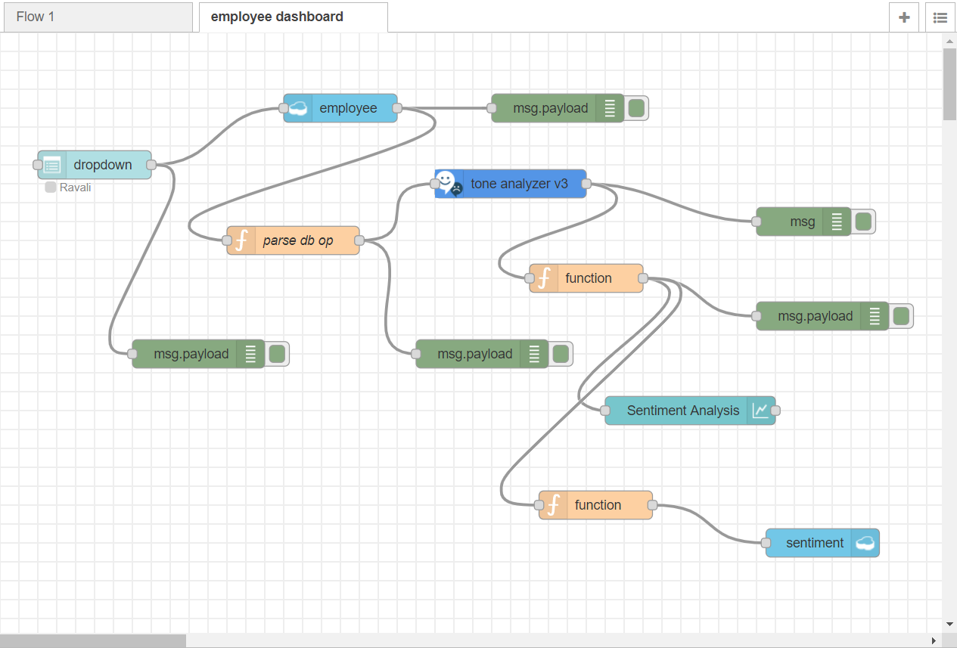

**6 RESULT**

**Employee DataBase:**

Here, we have created a database called employee, and created documents for five employees.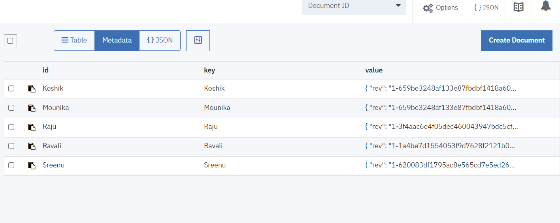

**Sentiment Analysis:**

Here , in the dashboard whenever we select the employee name analysis will be shown and at the same time sentements are stored in the Database.

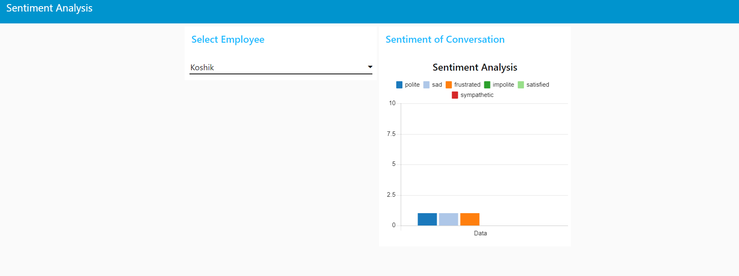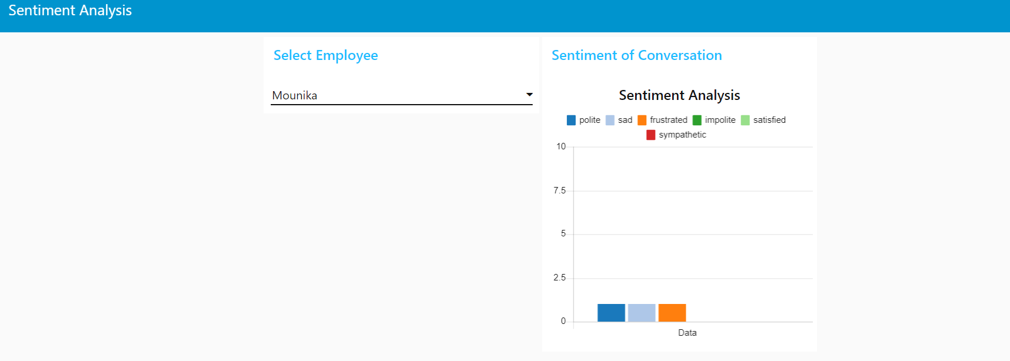



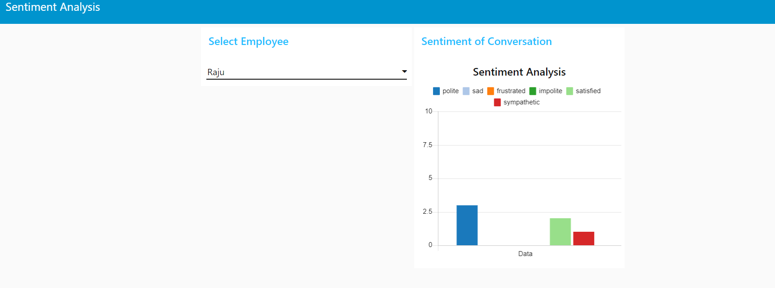

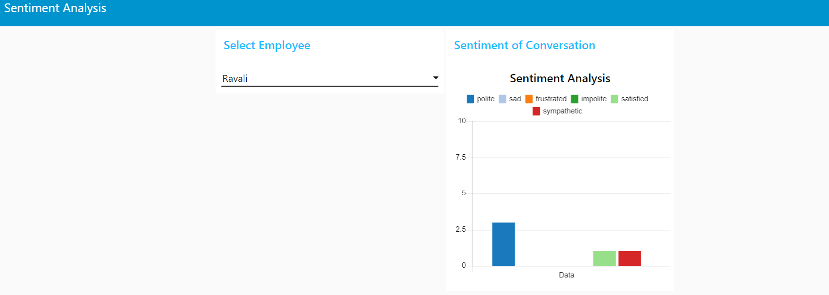

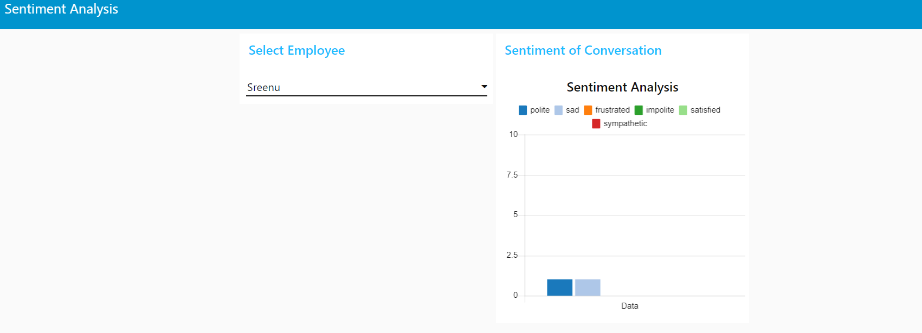

**Sentiment DataBase:**

This represents the data which is stored in the sentiment database.

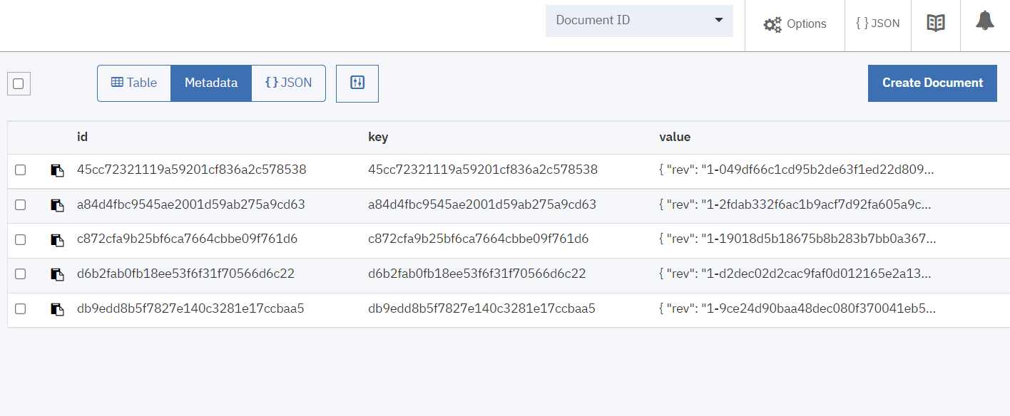

**7 ADVANTAGES & DISADVANTAGES**

**Advantages of Customer Satisfaction Surveys:**

* **Up-to-date feedback:** Gather current customer feedback on various aspects of your company. You can stay on top of customer trends through regularly scheduled online surveys or email surveys, and receive instant customer feedback. It is always useful to acquire insight into how your customers are currently reacting to all aspects of your business.
* **Benchmark results:** You can administer the same survey every so often to customers to gain continued insight into your customers. Surveys can have the same questions, which will allow you to compare data over time and benchmark survey data across previous years to determine if any changes need to be made.
* **Show that you care:** Customers like to be asked for their feedback.It gives the customer the perception that your company values them; is committed to keeping them as a long-term customer; and bases business decisions on their feedback.

**Disadvantages of Customer Satisfaction Surveys:**

* **Too many surveys, so little time:** Your customers are bombarded with online surveys. Surveys may be simple to complete, however, some people simply don’t like to complete them. Sending surveys too often can irritate customers and lead to customer burnout. Customer burnout can result in low response rates or result in lower satisfaction scores, despite your reputation for providing excellent products or services.
* **Privacy Issues:** We live in a high-tech environment filled with daily doses of unwanted junk email, email solicitations, and sales calls. When taking an online survey or a phone survey (or any type of survey), it is hard for your customers to believe that they aren’t being tracked. Because of insecurities of releasing private information, customers today are hesitant in giving out information that may lead to more junk email and unwanted calls. Make certain to assure customers that the information they provide in response to your customer satisfaction surveys will not be used. Without this disclaimer, it may be difficult to receive a good response rate.

**8 APPLICATIONS**

creating an employee recognition culture can increase employee retention by up to 31%. The appreciation analysis of each employee displayed on the Web application in the form of Bar charts.

**Employee recognition improves customer satisfaction:**

Employee satisfaction drives customer satisfaction. You all know, from your own experience, that employees who love their jobs and employers make much more effort to keep the customers happy as well.Therefore, appreciating your employees for good work has a direct impact on customer satisfaction. In fact, according to WorkHuman, 41% of companies that use peer-to-peer recognition have positive increases in customer satisfaction.

**Employee recognition improves employee health, well being and company culture:**

Employee recognition programs are a great way to improve employee health, satisfaction and well-being.

When leaders recognized employees’ healthy actions and outcomes, there was 91% improvement in population health and 87% improvement in medical plan cost than in companies that didn't recognize employees' success.

In addition, 85% of HR Leaders say an employee recognition program has a positive effect on organizational culture and 83% say that employee recognition programs benefit organizational values.

**9 CONCLUSION**

Employee satisfaction is the terminology used to describe whether employees are happy and comfortable and accomplishing their desires and needs at work. Employee satisfaction can also be based on the effect of an individual’s experience of work, or the quality of their working life. Employee satisfaction can be well understood in terms of its connection with some key factors, such as well- being, stress at work, control at work, working condition etc. employee satisfaction is based on how the [organization](https://www.ipl.org/topics/organization) treats them, effective employee satisfaction for individuals reflects from the emotional feeling they have about their job.

“client satisfaction indirectly effects employee satisfaction by effecting the perceived appreciation the employees receive from customers”. These observations have three major managerial effects; first, investment into customer satisfaction might settle double by enhancing revenue and profit on one hand, and improving employee satisfaction and retention on other hand. Second, positive customer feedback has positive effect on employee satisfaction and appreciation. Third, it is analysed that marketing and human resource issue are tangled in professional service firms. Creating satisfied and devoted customers will be useful for the organization, therefore allotting significant resources for employee and customer satisfaction and retention. However some researchers raise serious concerns about substantial prominence placed on both employee satisfaction and customer satisfaction and whether or not they relate to bottom line performance. In the case of hospitality and tourism sector attention to service and customer satisfaction is most important factor, it is expected to be a day- to day activity. This sector cannot run successfully without pampering their customers.

**10 FUTURE SCOPE**

1) To analyze complaints of customers towards products and services.

2) To collect the information of availability of particular product and services.

3) To find out the customer interest for the company's products.

4) To develop effective solution to the problems faced by customers.

**11 BIBILOGRAPHY**

**APPENDIX**

A. Source Code

**employee1:**

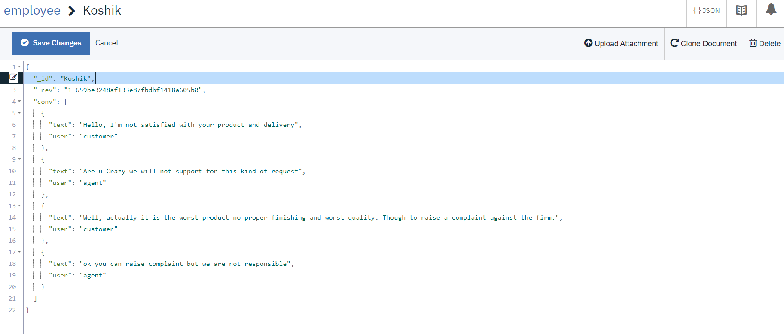

**employee2:**

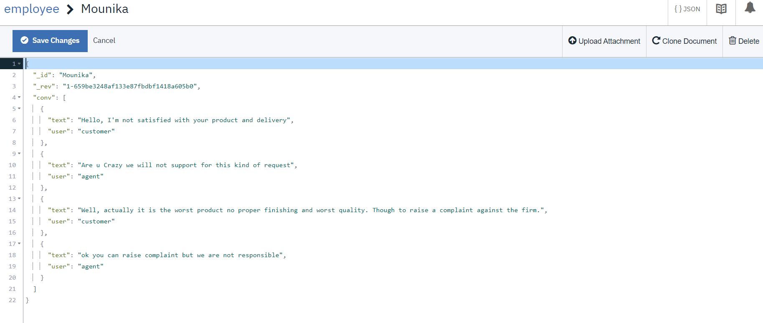

**employee3:**

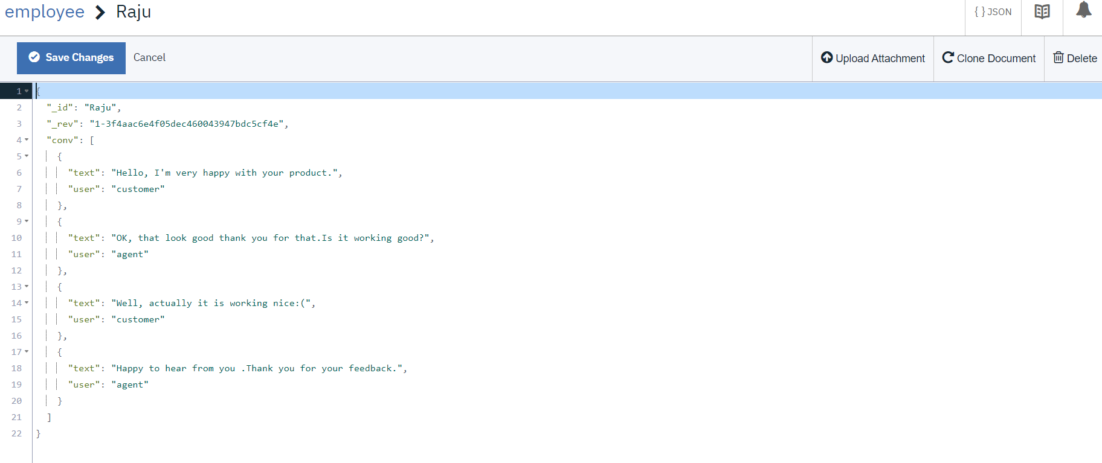

**employee4:**

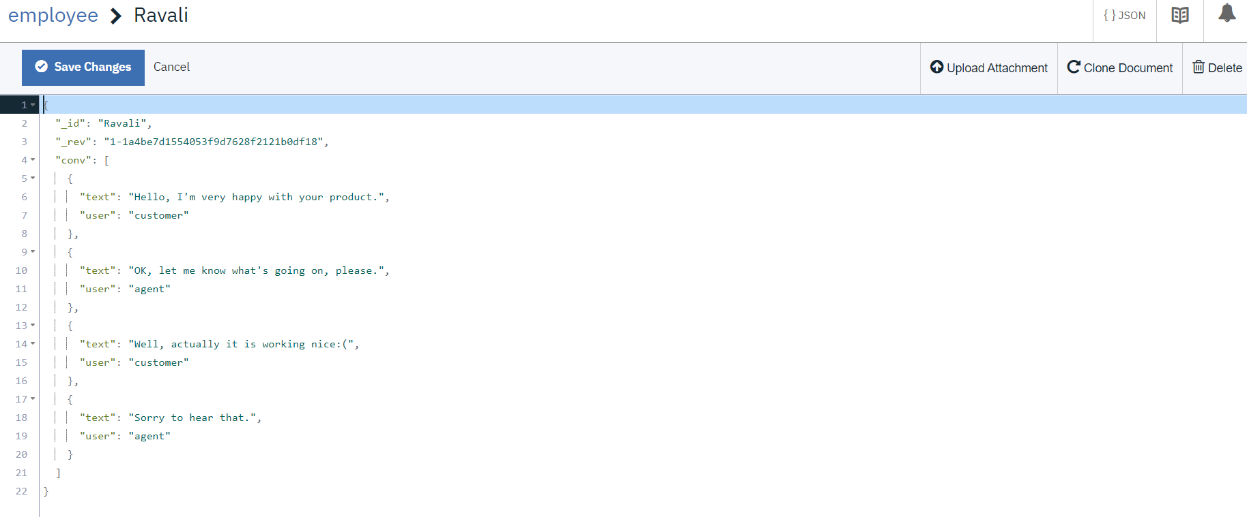

**employee5:**

